IMAGE RECOGNITION WITH IBM CLOUD VISUAL RECOGNITION

Development 2

***INNOVATION***

**IMPLEMENTATION** **OF** **THE** **COMPLETE** **FACE** **RECOGNITION** **SYSTEM**

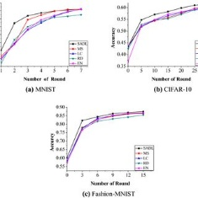In this section, we present the downsampling module usedto connect the detection and theRecognition subsystems.Then we describe the complete face recognition system.

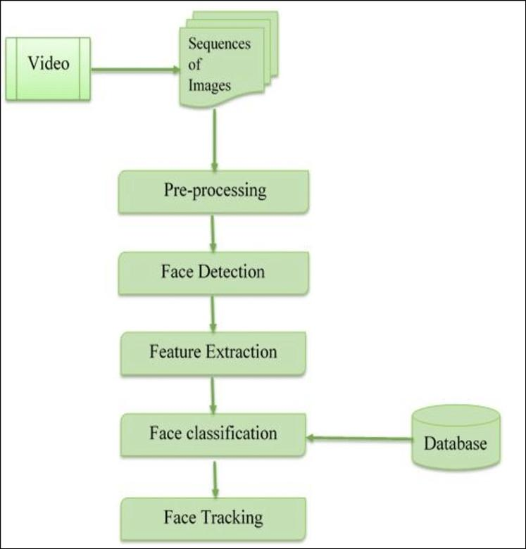**Performance** **comparisons** **between** **software** **and** **hardwareimplementations** **of** **the** **face** **Recognition** subsyste

**The** **architecture** **for** **the** **complete** **face** **recognition** **system** **consisting** **of** **the** **face**

**Detection** **and** **face** **recognition** **subsystems**

**Which** **is** a **combination** **of** **all** **of** **these** **subsystems**. **Provides** **an** **overview** **of** **the**

**Architecture** **for** **the** **completeface** **recognition** **system**.**The** **downsampling** **module** **is** **notified**

**When** a **face** **is** **detected** **by** **the** **face** **detection** **subsystem**. **After** **being** **notified**,**the**

**Downsampling module reads the face image data usingthe coordinates, width and height**

**Given by the face detection subsystem. According to the size of the detected face imageData,downsampling module reduces the detected faceto 20 × 20 and sends these 40 val**ues to **thefacerecognition subsystem. The downsampling module resizes eachDetected face so that they are suitable as input into the face recognition subsystem**

**We introduce a factor which is used to calculate how many pixels we should skipIn order to downsample a x×x image into a 20 × 20 image. The factor depends on the size ofDetected face. For instance, if the size of the detected face is 60 × 60, then the factor wouldBe 3. We can find the factor using f actor = detected f ace size/20. Finally, when theDetected face is appropriately downsampled, the downsampling module checks if the faceRecognition subsystem is busy. If the face recognition subsystem is available, it reads20 × 20 image and returns the index of a person which belongs to the detected face.According to the returned index of a person, we draw a box around the detected faceWith predefined color. Each individual’s face in the set is represented by an index and eachIndex is associated with a color.**

**The Implementation was simulated/verified with ModelSim, and then implemented onA Virtex-5 FPGA. Table I shows the device utilization of the complete face recognitionSystem on a Virtex-5 FPGA board. According to the experimental results, the complete faceRecognition system runs at 45 frames per second on VGA data.**

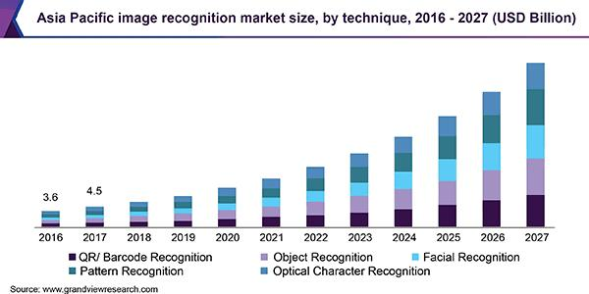

**Part (a) shows the latency of our face recognition subsystem implementation resultsOn an FPGA in milliseconds using both pipelined and non-pipelined implementations. Part(b) shows the latency cycles for pipelined and non-pipelined implementations. Part (c)showThe device utilization summary for the number of slices, LUTs, block RAMs (BRAMs) andDSP48s for both pipelined and non-Pipelined implementations.**

**DESIGN FOR IMAGE RECOGNITION:**

**F The module consists of a face recognition system that uses KNN algorithm tFind the closest probability to face acquired from the live feed. This system breaks the liveFeed into frames and each frame is applied to face detection process. The faceDetection process is used to identify a person by comparing the acquired face to theDirectory. The faces of the acquaintance stored in the directory is broken down to pointsAnd the points cumulatively provides the value to that person. By machine learningAlgorithm this data is trained to the system.**

**For the same person many images are feed to the machine as a training setBy thoroughly studying each angle of the image and deriving a value for the face weCan uniquely identify a particular person with a maximum probability of correctness .TheData obtained is transformed into audio file that is the final output of the proposed systemPresented to the visually impaired person .The heed by the visually impaired person throughA microphon**

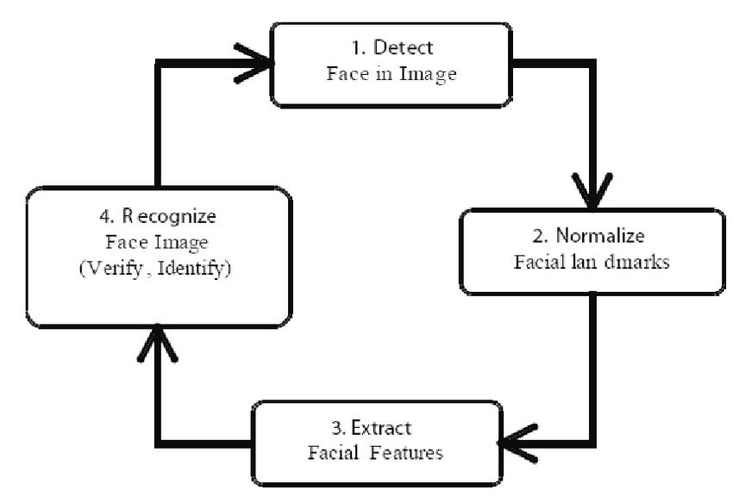

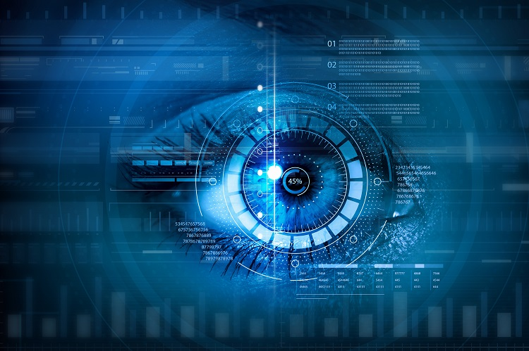

**For the same person many images are feed to the machine as a training set**

**By thoroughly studying each angle of the image and deriving a value for the face we**

**LCan uniquely identify a particular person with a maximum probability of correctness .The**

**Data obtained is transformed into audio file that is the final output of the proposed system**

**Presented to the visually impaired person .The heed by the visually impaired person through**

**A microphone or a speaker.**

**Coding:**

# This is a demo of running face recognition on live video from your webcam. import face_rec0U1itiM1 import cv2 import nt—y as rp

# Get a reference to webcam (the default one)

# Load a sample picture and learn how to recognize it.

# Load a second sample picture and learn how to recognize it.

# Create arrays of known face encodings and their names

1 kncm. face n.s

Barack %a.a" ,

"Joe Biden"

# Initialise some variables

face_encodings = [J face_rwnes = [J process_this fr— = True

*ile True:

# Grab a single frame of video ret, fr— = video_capture.read() # Resize frame of video to 1/4 size snall_fr— = cv2.resize(fr—, (O, O), fx=ø. 25, free. 25)

# Convert the image from BGR color to RGB color (which face_recognition uses)

if process_thi s_fr— :

# Find all the faces and face encodings in the current frame of video face locatims

Thank you